**Assignment 1 Result:**

Question 1:

AIM:

To create a program that generates 5 possible PAN Cards for a given name and condition.

# Code:

"""

Assignment 1 Question 1 done by Vansh Aggarwal

Date: 6/3/24

Time of start: 13:22

"""

#import

import random

# take inputs

temp = "ABCFGHLJPT"

i=1

name = input("Enter name: ")

print ('''

o A Stands for Association of Persons (AOP)

o B Stands for Body of Individuals (BOI)

o C Stands for Company

o F Stands for Firm

o G Stands for Government

o H Stands for HUF (Hindu Undivided Family)

o L Stands for Local Authority

o J Stands for Artificial Judicial Person

o P Stands for Individual

o T Stands for AOP (Trust)

    ''')

opt1 = input("Enter Letter of category: ")

# define all the functions

def check_3letters():

    x1 = random.randint(65,90)

    x2 = random.randint(65,90)

    x3 = random.randint(65,90)

    l3 = chr(x1) + chr(x2) + chr(x3)

    return(l3)

def check_4letter(o1):

    global opt1

    while True:

        if opt1 in temp:

            return(opt1)

        else:

            opt1 = str(input("Enter Letter of category: "))

def check_letter5(name):

    l = name.split()

    return(l[len(l)-1][0])

def seq_num():

    n1= str(random.randint (0,9))

    n2= str(random.randint (0,9))

    n3= str(random.randint (0,9))

    n4= str(random.randint (0,9))

    seq = n1+n2+n3+n4

    return (seq)

def check_digit (PAN):

    sum = 0

    for i in PAN:

        if ord(i)>= 65 and ord(i) <= 90:

            sum += ord(i)-65

        else:

            sum += int(i)

    rem = (sum%26) +64

    let = chr(rem)

    return (let)

# Main Loop for all functions

for i in range (5):

    PAN = str(check_3letters()) + str(check_4letter(opt1)) + str(check_letter5(name)) + str(seq_num())

    check = check_digit (PAN)

    print ("Possible PAN number" , i+1, PAN + check)

# Sample Output:

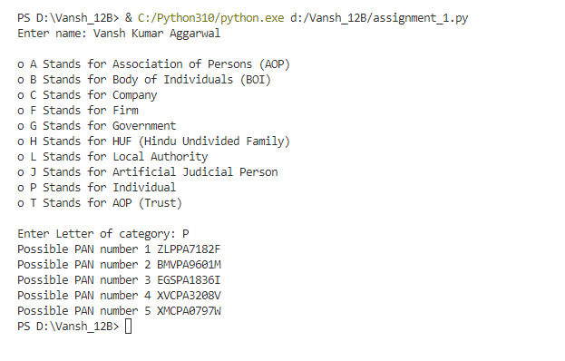

Question 2:

AIM:

To code a split function for a given string.

# Code:

"""

Assignment 1 Question 2 done by Vansh Aggarwal

Date: 15/3/24

Time of start: 11:53

"""

opt1 = 0

def string_to_list(main_string, split_string,opt1):

    i=0

    req_list = []

    temp = ""

    if opt1 == 1 or opt1 ==2:

        check_num = len (split_string)

        while i <= (len(main_string)- check_num):

            if main_string [i] == split_string[0]:

                main_string[i: (i+check_num+1)] == split_string

                req_list.append(temp)

                temp =""

                i+=check_num

            elif main_string [i] != split_string[0]:

                temp += main_string[i]

                i+=1

        req_list.append(temp)

    elif opt1 == 3:

        for i in main_string:

            if i != " ":

                temp += i

            elif i == " " and temp != "" and temp != " ":

                req_list.append(temp)

                temp = ""

    return (req_list)

while opt1 != 4:

    main_string = input ("Enter Main String: ")

    print('''

    1. split string value is a substring

    2. split string value is space

    3. split string value is not given.

    4. exit.

    ''')

    opt1 = int(input("Enter option number: "))

    if opt1==1:

        split_string = input ("Enter the split string: ")

    elif opt1 ==2:

        split_string = " "

    elif opt1 ==3:

        split_string = " "

    elif opt1 == 4:

        break

    else:

        print ("input not recognised")

        break

    print (string_to_list (main_string, split_string,opt1))

# Sample Output:

